**A**

**Detailed report**

**On**

**“sRide carpool app”**

**Prepared by**

**Raghu Naluvala**

https://sride.co/wp-content/uploads/2019/05/logo-e1559135006232.png

Table of Contents

Chapter 1 3

SRIDE Carpool App 3

Chapter 2 4

How sRide made to #1 in India 4

2.1 Core values of sride 5

Chapter 3 7

Why Choose Sride Carpool 7

Figure 1 core values 5

Figure 2 prime focus 7

# 

# Chapter 1

# SRIDE Carpool App

sRide company was founded on oct 1 2014 by ‘lakshna Chadha jha ‘ , the main focus of the app is to reduce traffic, pollution and save environment

The company has tie-ups with corporate companies such as Infosys, Wipro [Capgemini](https://en.wikipedia.org/wiki/Capgemini), Cognizant and others to offer regular carpooling rides to employes. As per a research conducted by sRide, an average vehicle’s seat utilization in India in 2018 was at about 25% which means only 1 out of 4 seats was occupied in a car in 90% cases.

On 12 August 2016, sRide raised $1 million in funding from angel investors.

As of june 2019, sRide raised $5.2 million in funding as per the crunchbase.com

# Chapter 2

# How sRide made to #1 in India

Despite having 10 competitors in India sRide became leading app in carpooling industry.

Why is sRide Carpool App better than the rest:  
  
* Instant matches Offer a Ride - Post a ride in just 1 step and get INSTANT ride matches for your carpooling / car sharing. Option to select your co-rider based on their review & rating.  
* Bike pool – India’s only app with integrated carpooling and bike pooling in 1 app. Find the most convenient to pool at fraction of a cost   
* Recommendation & Notification – sRide is powered with an advanced recommendation engine that keeps you updated about rides near you.   
* Safety – With our multi level verification process, we make sure that you Carpool with verified & safe users. The 2 way review is mandatory for every user after completing each carpool ride.   
* Chat – sRide Carpool App allows you to use chat within the app to communicate with your carpool co-riders. No more calling required. Just chat & carpool  
* Address Search – Search rides for the addresses you want  
* Promotion & Referral – Refer your friends / colleagues to sRide using in-app referral system and get free sRide points that can be used to pay for future carpool rides.  
* Online Payment – 1st app in India to be integrated with online wallets making your carpool ride cashless & hassle free.

# 2.1 Core values of sride

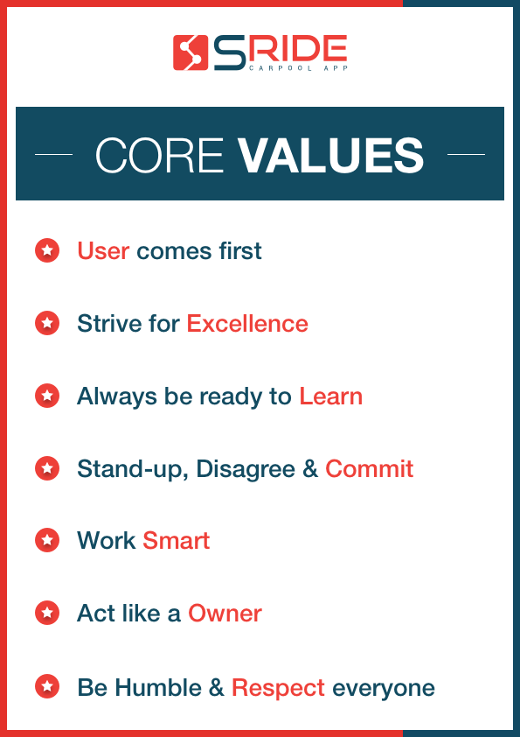

Figure 1 core values

sRide is not about innovation… its about disruption. In our strive to be the leading and most impactful shared mobility platform, sRide set out on a journey 4 years back which is no lesser than a sky dive. It’s a leap of faith because you have a strong faith in the parachute – parachute being your passion, vision and your team in this case.  sRide is built on strong pillars of user experience, excellence and vision.

* Users Comes First: User is the King. sRide strives to make commuting hassle free by helping people to share via carpool and bikepool
* Strive for Excellence: It is ‘the quality of being outstanding or extremely good’. We strive for excellence every single day
* Always be Ready to learn: Learning is a life-long process and the only way to get better.
* Stand-up, Disagree & Commit: Every individuals need to present his view, agree/disagree while a decision is being made irrespective of their designation in order to create the best decision and once that decision is made, commit 100% to it
* Work Smart: Smart work aims for the same results but with proper planning and prioritization in order to reduce repeat work
* Act like an Owner: It’s very important to take ownership of even smallest of the tasks. When organizations are filled with internal leaders who think and act like owners, work is more meaningful, rewarding, and enjoyable.
* Be Humble & Respect Everyone: We accept our mistakes. Listen More , Talk less and acknowledge the fact that we don’t know all the answers and are always open to constructive Feedback.

# Chapter 3

# Why Choose Sride Carpool

At sRide the prime focus has always been easy to use and simple user experience. We always try our best to balance between features and

* Real Time Tracking
* Safety Tool Kit
* 1 Click Ride Post
* Verified Riders
* 24*7 Support
* Better Matching Algorithm
* New Friendly UI

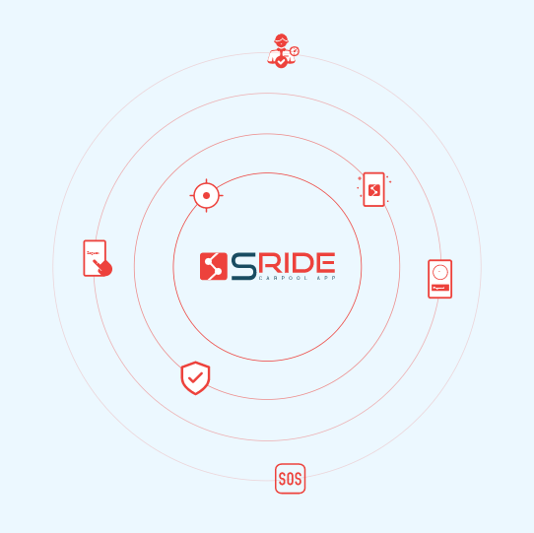

Figure 2 prime focus